Mediashippers Marketplace
Internal Marketplace Operations Documentation
STEP 6 — REVIEW, VALIDATION & FINAL SUBMISSION WORKFLOW

Reference Workflow Interface
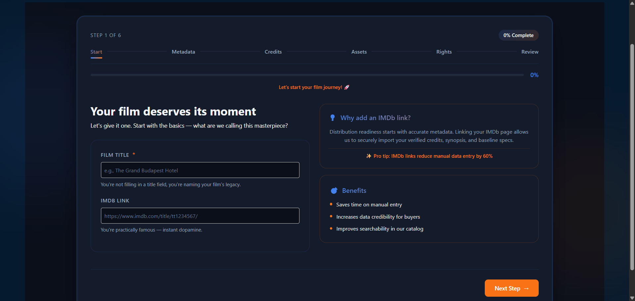
Figure 6.0 — Final Review & Submission interface used before marketplace publishing.

1. Purpose & Core Philosophy
The Review & Submission workflow represents the final operational checkpoint before a title becomes eligible for marketplace discovery, licensing activity, recommendation ranking, and buyer engagement. This workflow validates whether all metadata, rights configurations, promotional assets, credits, and compliance requirements satisfy Mediashippers publishing standards.
The primary objective of this stage is to reduce incomplete or legally invalid submissions while improving buyer confidence and marketplace presentation quality. Every workflow section contributes to a centralized readiness scoring system that determines whether a title may proceed to publication.

2. Marketplace Submission Objectives
- Prevent incomplete titles from entering discovery pipelines
- Improve buyer trust through standardized validation
- Ensure licensing configurations remain legally compliant
- Verify metadata completeness and discoverability readiness
- Validate promotional assets and commercial positioning
- Support automated moderation and marketplace approval workflows

3. Submission Completion Workflow
The Mediashippers onboarding system follows a structured six-stage workflow. Each stage contributes to the final marketplace readiness percentage.
Workflow Stage | Operational Purpose
Start Screen | Core title identity and IMDb reference collection
Metadata Screen | Synopsis, genre, language, and runtime validation
Credits Screen | Director, cast, producer, and writer verification
Assets Screen | Poster, trailer, banner, and subtitle upload checks
Rights Screen | Territory, licensing term, and exclusivity validation
Review Screen | Final compliance checks and publishing readiness

4. Metadata Summary Validation
During the review stage, the platform automatically generates a metadata summary panel containing all commercially important information associated with the title.
Validation Field | Operational Importance | Marketplace Impact
Title | Primary marketplace identity | Supports catalog discoverability
Type | Content classification | Determines distribution workflows
Genres | Recommendation filtering | Improves buyer targeting
Language | Regional licensing compatibility | Supports territory discovery
Release Period | Commercial positioning | Improves recommendation ranking

5. Assets & Marketability Review
The platform evaluates promotional assets and commercial positioning data before allowing marketplace publication. Strong visual assets increase buyer engagement, watch intent, recommendation visibility, and professional presentation quality.
- Poster artwork is mandatory for marketplace publication
- Trailer uploads improve buyer engagement and viewing interest
- Banner assets support premium placement eligibility
- Subtitle files improve international licensing readiness
- Commercial positioning metadata influences recommendation ranking
- Awards and platform history increase marketplace attractiveness

6. Credits Summary Verification
The Credits Summary module validates the creative and commercial personnel associated with the title. Talent metadata directly influences buyer trust, marketability scoring, and discoverability.
Credit Type | Marketplace Importance | Commercial Impact
Directors | Mandatory | Required for submission approval
Producers | Medium | Supports financing credibility
Writers | Medium | Improves metadata completeness
Cast Members | High | Improves commercial discoverability

7. Rights Configuration Review
All licensing structures undergo automated validation before publication. The Rights Configuration panel confirms whether the title is legally clear for marketplace licensing and territory distribution.
Rights Parameter | Example Validation Logic | Operational Impact
Available Rights | Checks overlapping exclusivity conflicts | Prevents double licensing
Target Regions | Validates territory clearances | Protects regional legality
License Duration | Checks expiration compatibility | Avoids invalid contracts
Exclusivity | Blocks duplicate licensing conflicts | Protects premium rights
Dubbing Rights | Requires seller localization approval | Controls localization legality

8. Completion Progress & Readiness Logic
The completion tracker visually represents the submission readiness percentage. Each onboarding module contributes to the final marketplace eligibility score.
- Incomplete sections reduce discoverability readiness
- Rights validation must pass before submission approval
- Missing posters automatically block marketplace publication
- Critical metadata fields remain mandatory
- Completion indicators update in real time
- Moderation systems may trigger additional manual review
- Marketplace publishing remains locked until all required validations pass

9. Marketplace Publishing Rules
Titles may only proceed to marketplace publication after all compliance, rights, metadata, and operational validation checks are successfully completed.
- Rights conflicts automatically prevent publication
- Expired licensing windows are rejected
- Duplicate title submissions are blocked
- Incomplete metadata lowers approval priority
- Moderation systems may request manual review
- Improper asset formatting may trigger validation failure
- Territory conflicts block licensing availability

10. Dummy Review & Submission Example
Submission Field | Dummy Example
Title | The Last Signal
Genre | Sci‑Fi Thriller
Language | English
Poster Status | Uploaded
Trailer Status | Uploaded
Rights Package | Exclusive SVOD Rights
Territories | Worldwide excluding China
Submission Readiness | 100% Complete

11. Final Marketplace Readiness Philosophy
Marketplace readiness is not determined solely by metadata completion. The platform evaluates legal clarity, discoverability quality, commercial presentation, territory compliance, localization readiness, and buyer-facing professionalism before allowing publication.
Titles that maintain complete metadata, strong promotional assets, validated rights configurations, and professional commercial positioning generally receive stronger recommendation visibility and improved licensing engagement.

12. Internal Training Notes
This document is intended solely for internal onboarding and workflow training purposes. All titles, metadata structures, licensing examples, commercial positioning data, and rights configurations used throughout this document are fictional and created strictly for simulated marketplace education.
Interns reviewing this workflow should understand how marketplace readiness directly impacts discoverability, licensing opportunities, buyer confidence, recommendation systems, and operational approval pipelines.
CONFIDENTIAL — MEDIASHIPPERS INTERNAL TRAINING & MARKETPLACE REVIEW OPERATIONS DOCUMENT

